input.doc Name_________________________

During an experiment the temperature of a substance is measured each minute for a ten minute period.
Temperature in degrees Celsius is a function of time in minutes: c=f(m).

1) Explain the meaning of each of the following in terms of time and temperature. Include units.

a) f’(3) = 2
at 3 minutes the temperature is increasing by 2º C per minute

b) f’(5) = -3
at 5 minutes the temperature is decreasing by 3º C per minute

c) f’(8) = 0
at 8 minutes the temperature is not changing

2) What would it indicate about the sign (+, -, or 0) of f’(x) and f’’(x) if each of the following were true for the duration of the experiment?

a) The temperature is increasing by less than it did the previous minute.
time
temp

f’(x) = + f’’(x) = - sketch:

b) The temperature is increasing by more than it did the previous minute.
time
temp

f’(x) = + f’’(x) = + sketch:

c) The temperature is decreasing by less than it did the previous minute.
time
temp

f’(x) = - f’’(x) = + sketch:

d) The temperature is decreasing by more than it did the previous minute.
time
temp

f’(x) = - f’’(x) = - sketch:

e) The temperature is increasing by the same amount as it did the previous minute.
time
temp

f’(x) = + f’’(x) = 0 sketch:

3) Your grade (as a %) on a test is a function of the amount of time in hours spent studying g=f(t).
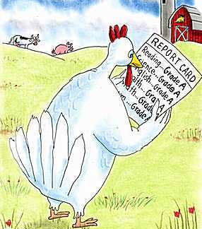
time
grade

What is the meaning of f(2) = 90?

If you study 2 hours you will get a 90%

What is the sign of f’? + What does it suggest about studying?

If you study more hours you will improve

What is the meaning of f’(2) = 5?

At 2 hours your grade will increase by 5 points per additional hour of studying

What is the sign of f’’? - What does it suggest about studying?

Each additional hour of studying, your grade will increase by a smaller amount

What is the meaning of f’’(2) = -3?

At 2 hours of studying your grade will increase by 3 points less than it did by studying the previous hour.
(The rate of improvement is decreasing.)

